**Associate of Applied Science Degree in**

**Automotive Engine/Block & Cylinder Head Machining**

**General Education Textbooks**

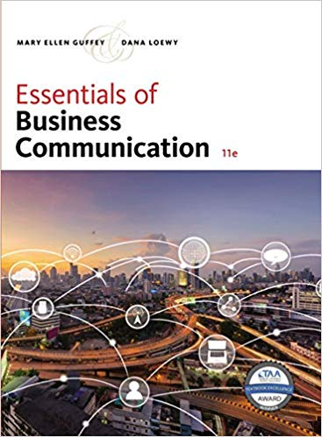 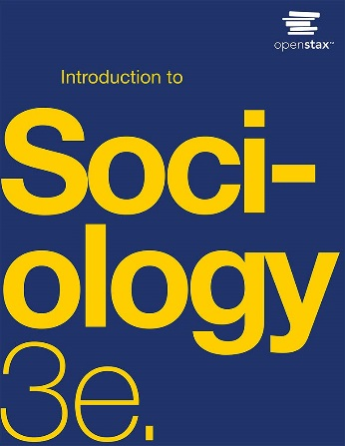

ISBN-13: 978-1337386494 ISBN-13: 978-1-711493-97-8

 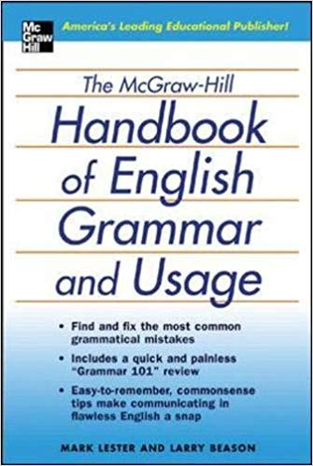

ISBN-13: 978-0133800333 ISBN-13: 978-0071441339

 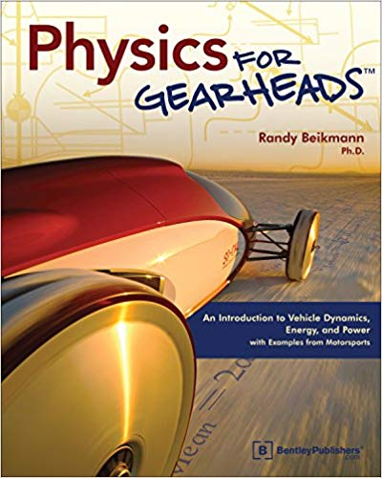 

ISBN-13: 978-1506698090 ISBN-13: 978-0837616155 ISBN-13: 978-1938168383